Software Requirement For Warehouse Inventory Management

Objective

To record the movement of stock in, out, and within a warehouse. Stock will be held and moved in boxes and pallets in any combination and these will be located in a bay on racking in the warehouse. The system must record where an item is, in which box or pallet and what location. Movements in and out of the warehouse are recorded against and customer and order reference.

Unit Descriptions

The following descriptions describe the units used to hold and move stock around our warehouse. Each unit is individually recognised by a barcode either fixed to the item or its container as described. The warehouse is fully racked to take pallets and all ‘bays’ are labelled.

You may be better to refer Items as SKU’s (Stock Keeping Units) as this is industry standard. You may also want to refer Boxes & Pallets as ‘Stock Keeping Units’ which could be user defined. In some real world situations you may need more of these (but not that many!). Some warehouses may have ‘BINS’ for storing ‘loose’ very small items.

In some other examples for eCommerce, a warehouse could be split up into ‘bulk’ storage (possibly one item per pallet), and ‘picking’ location where the ‘bulk’ storage can be split up into for easy picking by order processing staff.

Items
Individual stock items referenced by a supplier’s catalogue number or barcode. Items may be placed in quantity directly on a pallet OR in boxes on a pallet. It is possible to have different items in the same box which is on a pallet with other boxes.

Boxes
A box can contain one item or a collection of different items. Boxes will be placed on pallets. Box structure BX99999999. A default reference of BX00000000 will be used to identify items which have no box. These items may be placed directly on a pallet or moved into a box at another stage.

Pallets
A pallet can hold boxes which contain items or they may contain items only. Pallet Structure PA99999999. A default reference of PA00000000 will be used for items/boxes which are not on a pallet or not allocated a pallet yet. These items may be placed on a pallet at another stage.

Locations
A location is a bay which may hold a number of pallets. Location structure AA-A-99-99. A default location code of AA-A-00-00 will be used as a quarantine location or for items/pallets which have not yet been given a location. This allows for stock to be received into the warehouse, boxes and pallets built and then moved to their final location. This may be carried out with add transactions followed by a move.

When we had this system in operation we needed a ‘transition’ location to record stock having been removed from the warehouse but not yet booking into its final location (i.e. the Garden Centre).

You might want to add a WAREHOUSE name/address as well as a COMPANY/ORGANISATION at the top of this tree. For example, a company could have more than one warehouse/address and within this locations, pallets, boxes, items etc. If this were cloud based and selling this it would be based on Company/Location and they would have to pay for number of SKU’s(items), number of warehouses and number of users. security would be a key consideration as well as logging all user activity and stock movements.

As you can identify by these descriptions there are many ways in which items may be combined on a pallet. The function of this system is to manage the movement of stock by these units so that an item may be pin-pointed to a location/pallet/box and located quickly.

Stock Master File

A stock master file can be created/updated from a provided CSV file (VECSTOCK.TXT) from VECTOR.

STOCK_ID Unique stock ID (long integer)
DECRIPTION Description Alpha 65
SIZE_UNIT Size Text AN 15
DEPARTMENT Department Description AN 150
SUPPLIER Supplier Name AN 65
CAT_NUM Catalogue Reference AN 40
COST_NET Cost Price (Net) C
COST_AVG Cost Price (Average) C
SELL_PR Selling Price (incVAT) C
CREATED Date Record Created D (DD/MM/YYYY)
CHANGED Date Record Changed D (DD/MM/YYYY)
VAT_ID VAT Code AN 4

Stock Barcodes File

Created/updated from file provided as CSV file (VECBARCD.TXT) from VECTOR

STOCK_ID Unique Stock ID LI
(Linked to Stock Master)
BARCODE Barcode (unique) AN 30

WAREHOUSE PALLET RACKING ILLUSTRATION

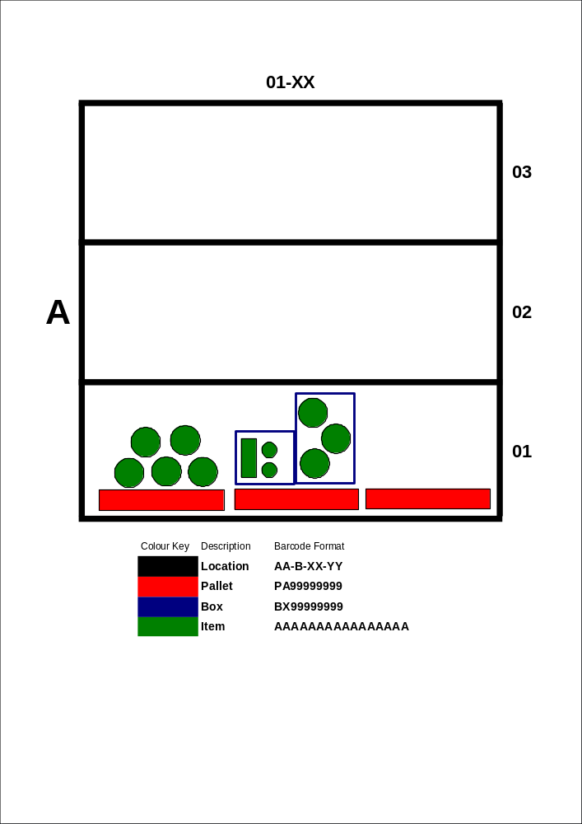

Menu Required

- Add Stock
- Remove Stock
- Move Stock
- Adjust Stock
- Stock Enquiry

- Import Order for Picking
- Import Stock
- Export Stock

- Perform Stock Check

- Report - Stock Valuation By Department
- Report - Stock Valuation By Supplier
- Report - Stock List By Location
- Report - Stock Movements
- Report – Stock Exceptions

Add Stock

Stock will need to be added (received) into our warehouse either directly using a form on the PC or imported from a CSV file generated by a HHT (Hand Held Terminal).

To add stock through a form:

- Account (Supplier Account)
- Reference (Order Number or Delivery Note):
- User ID
- Date
- Time
Repeat The Following Until Order Complete:
- Item Code (either barcode or catalogue number)
- Enter a quantity
- Box ID Code (in format BX99999999) <Optional>
- Pallet ID Code (in format PA99999999) <Required>
- Location ID Code (in format A-A-99-99) <Required>

The format of the CSV file (ADD.TXT) generated is as follows:

- Account A 30
- Reference A 30
- User ID A 8
- Date D DD/MM/YYYY
- Time T HH:MM
- Item Code A 30
- Box ID A 10
- Pallet ID A 10
- Location ID A 10
- Quantity S 8

Remove Stock

Stock will need to be removed (issued) from the warehouse either directly using a form on the PC or imported from a CSV file generated by a HHT.

- Account (Customer Account)
- Reference (Order Number)
- User ID
- Date
- Time
Repeat the following until request complete:
- Item Code
- Box ID
- Pallet ID
- Quantity

The format of the CSV file (REMOVE.TXT) from the HHT is as follows:

- Account
- Reference
- User ID
- Date
- Time
- Item Code
- Box ID
- Pallet ID
- Location ID <Not Required>
- Quantity

Move Stock

This function facilitates the need to move stock around the various locations of the warehouse. Again this should be done either with a form on the PC or imported from a CSV file generated by a HHT.

To move stock via form on PC:

- Reference
- User ID
- Date
- Time
Repeat the following until process completed:
- From Item ID
- From Box ID
- From Pallet ID
- Quantity Moved
- To Box ID
- To Pallet ID
- To Location ID

The format of the CSV file (MOVE.TXT) from the HHT is as follows:

- Reference
- User ID
- Date
- Time
- From Item ID
- From Box ID
- From Pallet ID
- Quantity Moved
- To Box ID
- To Pallet ID
- To Location ID

The tricky bit on moving stock in the warehouse is handling the move with the minimum of information i.e. to move a pallet should require just the ‘From Pallet ID’ and the ‘To Location ID’. So the following permutations need to be handled:

To move an item:
From Item ID
From Box ID (optional)
From Pallet ID (required)
Quantity Moved
To Box ID (optional)
To Pallet ID (required, default to from Pallet ID)
To Location ID (required)

To move a box (and all its contents):
From Box ID
To Pallet ID
To Location ID

To move a pallet (and all its contents)
From Pallet ID
To Location ID

Stock Enquiry

This option is to provide a facility to search for a stock item and for it to present a table showing the quantities held at various locations.

Provide a form to request the following:

Item ID (to search for stock via barcode, catalogue no. or description)

When item is found show the following information:

Total quantity in warehouse
First date added to warehouse
Last date removed from warehouse

Then list all locations of stock in warehouse down to location, pallet and box ID with quantity in each.

Show history of quantity additions to the warehouse
Show history of quantity removed from warehouse

Import Order for Picking

This option will import a CSV file containing an order request for picking. This will produce a picking list indicating warehouse locations. From this stock will be removed from the warehouse using the remove stock option.

The format of this CSV file (ORDERS.TXT) is as follows:

- Account
- Reference
- Date
- Time
- Stock ID
- Quantity

Produce report grouped by Account & Reference showing the following in location order:

- Location ID
- Pallet ID
- Box ID
- Quantity

Highlight where not enough stock to fulfil order.
Show more than one location for an item if required to fulfil order.

Import Stock

This option should take two CSV files and is required to add or update master stock records for Stock Master and Stock Barcodes. There is no requirement to update the stock records directly. Any changes will be made in VECTOR and updated in the WHMS via CSV files.

Stock Master CSV file (STOCK.TXT) format:

- STOCK_ID Unique stock ID
- DECRIPTION Description
- DEPARTMENT Department Description
- SUPPLIER Supplier Name
- CAT_NUM Catalogue Reference
- COST_NET Cost Price (Net)
- COST_AVG Cost Price (Average)
- SELL_PR Selling Price (incVAT)
- VAT_ID VAT Code

If the STOCK_ID matches record in WHMS then update all fields. If no STOCK_ID found than add a new stock record.

Barcodes CSV file (BARCODES.TXT) format:

- BARCODE Barcode (max 22 characters)
- STOCK_ID Reference to stock master

If BARCODE matches record in WHMS then update all fields. If no BARCODE record found then add a new record.

Export Stock

This requirement generates a simple CSV file containing stock levels which may be imported into VECTOR for analysis.

This CSV file (WHEXPORT.TXT) should conform to the following:

- STOCK_ID Unique stock reference
- QTY IN STOCK Total quantity in stock at warehouse

Stock Check

This function is to allow for the stock levels to be checked periodically in the warehouse.

The report produced should following the following format:

Fields to display:
- Location ID
- Pallet ID
- Box ID
- Item Description
- Catalogue Reference
- Quantity

Grouped By:
- Location ID

Sorted By:
- Location ID
- Pallet ID
- Box ID
- Item Description

Selection Criteria:
- Location ID

Reports

Stock Valuation By Department

Fields to Display:

Grouped By:

Sorted By:

Selection Options:

Stock Valuation By Supplier

Fields to display:

Grouped By:

Sorted By:

Selection Options:

Stock Listing By Location

Fields to display:

Grouped By:

Sorted By:

Selection Options:

Stock Movements

Fields to display:

Grouped By:

Sorted By:

Selection Options:

Stock Exceptions

Fields to display:

Grouped By:

Sorted By:

Selection Options:

